Royal Hotel
46 Grace Street Herberton 4887
Est. June 1880
First hotel established in Herberton.
Built for McColl and Hides, Hides susbsequently sold up and established Hides Hotel in Cairns which still stands today.
2nd story added 1914.
Mona Moss was the longest serving publican 1945 – 1972.
In 1970, Jim O’Dwyer the publican at the time bought the land beside the hotel and set up the beer garden. The Crystal Palace shop was originally on this site. In 1899 Armstrong, Ledlie & Stillman set up their shop which traded until 1970.
Today the Royal Hotel is the oldest continuously licenced premises on the Tablelands.
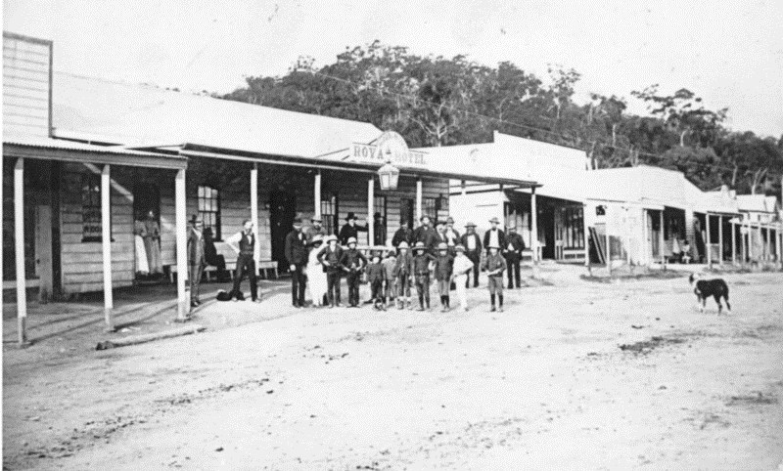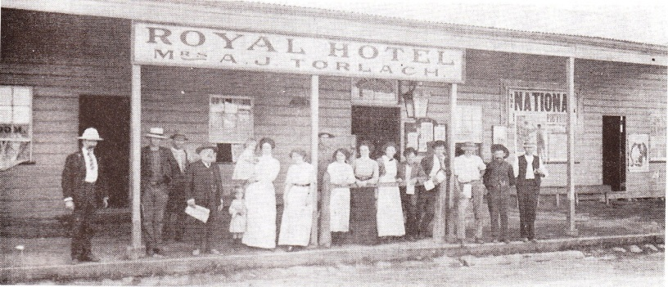
1888 1913

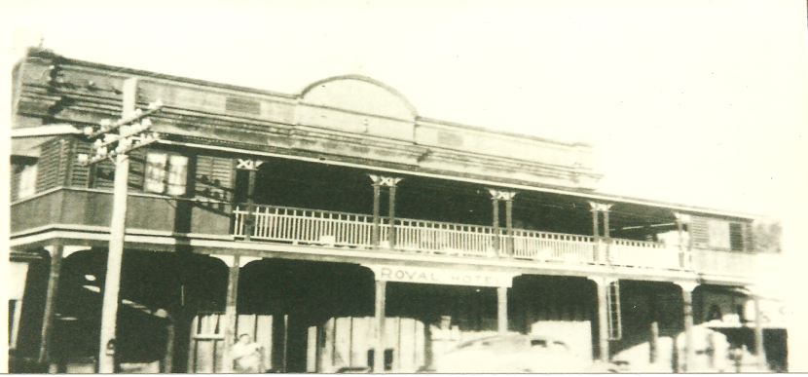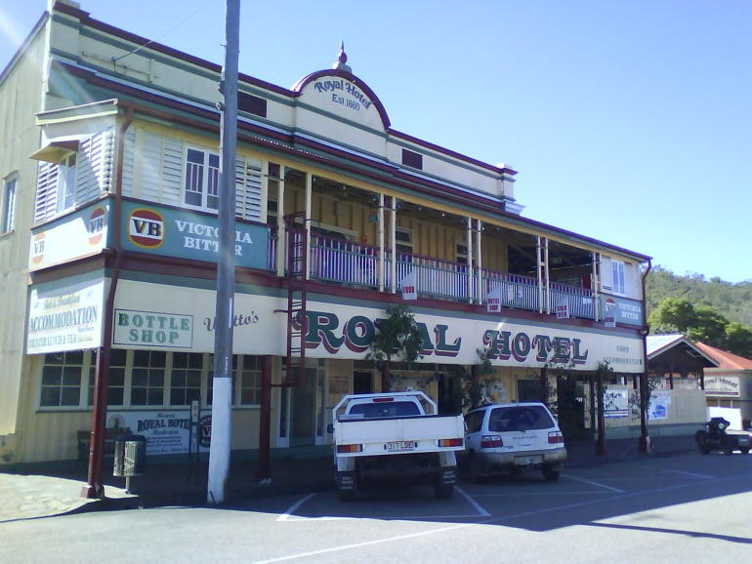
1947 2009

